Spring 2021 Harvest Guidelines for Mille Lacs
Due to the COVID-19 pandemic, and in effort to keep our communities as safe as possible, we have updated the harvesting guidelines for this year’s spring harvest season. We humbly ask that all Mille Lacs Harvesters respect and comply with this plan.
After internal discussion, the decision was made to not ask the Wisconsin and Fond du Lac tribes to travel to Mille Lacs Lake this year. All eight of the 1837 signatory Band’s have expressed interest and intend to travel to Mille Lacs Lake for the spring harvest. With that being said, in order to minimize the spread/risk of COVID-19, we ask Mille Lacs tribal harvesters to only use the landings identified below. We realize that some MLBO harvesters enjoy harvesting at off reservation landings, but encourage harvesting at on reservation landings in effort to continue to slow the spread of the virus between communities. The intention is not to prevent or limit anyone from exercising their Treaty rights, but is to protect the health and safety of our communities. All of the Wisconsin Band’s, along with Fond Du Lac and Mille Lacs Band are working on creating processes to keep our communities at designated areas and to demonstrate social distancing at landings.
Open landings for a particular day will be determined by a committee consisting of DNR staff, tribal harvesters and Elders. Considerations for the open landing will include: weather, wind and ice. Please respect the decision of the committee as we want to ensure the safety of our communities. The committee will determine what landings are open by 9am, and will notify harvesters via text alert system.
Due to limited creel teams, staff numbers and safe distance practices, up to 4 landings may be declared per day. It is our goal to only declare on reservation landings, but realize off reservation landings may be declared. Please know, we are attempting to reduce the spread of COVID-19 and appreciate your understanding in these challenging times. It is likely off reservation landings will be declared by Fond Du Lac or Wisconsin Band’s, and if MLBO harvesters choose to harvest at the same off reservation landings, please let MLBO DNR know so we can be sure to have a creel team available as we are doing the best we can to keep our communities safe. In event of high winds or other factors that may limit accessibility to the designated landings, we may move to another landing. Please contact Commissioner of DNR, Katie Draper at 320-515-0846 and she will address appropriately.
Harvester DNR Text Alerts – We will communicate via our Text Alert system and share which landings are declared. Once landings are declared, please let us know as soon as possible (instructions below), the method you intend to harvest at the open landings. Make sure you update your phone number by contacting Alyssa Welsh, 320-362-1514. If you do not want to sign up for Harvester DNR Text Alert’s please notify your preferred contact information.
Declaring a Landing – Beginning this year, harvesters can declare a landing 7 days a week (including Art Gahbow Day holiday). Harvesters must complete the Landing Declaration Form by 11:00am daily to allow DNR staff adequate time to notify GLIFWC/State.
- Via Google Link (recommended method): Mille Lacs Band of Ojibwe Declaration Form
- By phone: DNR Headquarters, D1: 320-532-7439
Steven Aubid, D2: 320-364-4123
Vanessa Gibbs, D3: 320-362-4647
Please note: You do NOT need to physically come to the DNR Headquarters to pick up your permit as they will be issued at landings. Once you declare a landing for NETTING: During harvesting season there will be DNR staff member from 5:30-7:30pm to distribute permits at said landing. You must pick up your netting permit within that time. Make sure you have your tribal ID handy. SPEARING: During harvesting season spearing permits will be issued (same as previous years) at declared landings beginning at 8:00pm.
IF you need to cancel, it is your responsibility to contact any of the DNR Conservation Officers as soon as you are aware. Continued “no shows” to landings could hinder permits issued to you. CO contact numbers: Jason Rice: 320-630-2619, Ashley Burton: 218-838-3379 or Jeffery Schafer: 320-630-2463.
What to expect at the landings
- In effort to keep crowds down to a minimum, harvesters are asked to remain in their vehicle while waiting to launch their boats. Please make sure your boat is ready to launch for when it is your turn.
- While waiting in line to creel fish, maintain social distancing guidelines by keeping 6 feet between you and other harvesters.
- Harvesters will have the opportunity to creel their own fish along with a certified creel monitor if they wish to do so to minimize exposure to others. If there are only a few harvesters at a landing at one time, they may not be asked to assist with their creel.
- Harvesters are asked to keep their time spent at the landing to a minimum. This will keep the flow of people coming and going.
- Harvesters will be highly encouraged to wear a mask.
Fish Dump –Harvesters are asked to use the fish dump. If fish are left at locations other than the fish dump, it creates unpleasant work for others. The dump is off County Road 2 near Whitefish Lake. Copies of the map to the dump will be provided at landings for those that need to verify the location. See map. Miigwech for your cooperation!

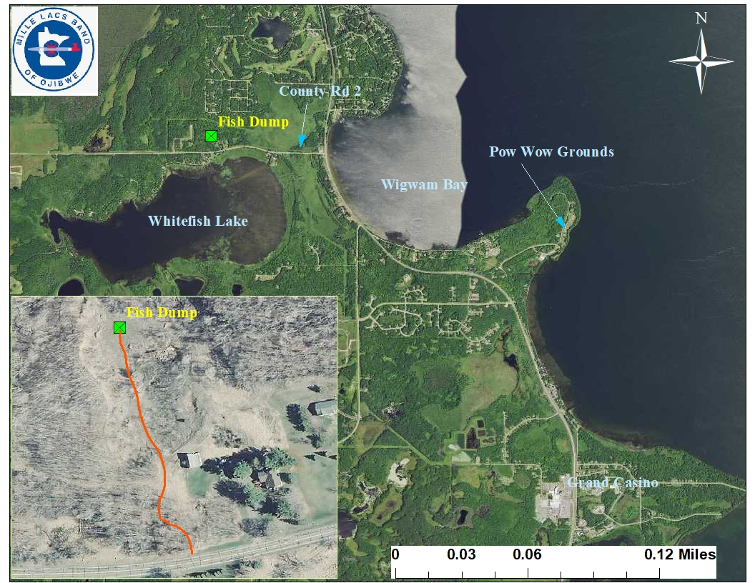

Don’t forget to put your asemaa down, treat your nets and fish as you would your most precious loved ones. Your patience and understanding is appreciated. There is a lot to consider this harvesting season for all of our communities, and we at the DNR appreciate you working together to keep our communities as safe as possible. Hopefully these safe harvesting practices will continue to aid in slowing the spread/risk of COVID-19 to our communities. If you have additional questions or concerns, please contact Katie Draper, Commissioner of DNR at 320-515-0846. Miigwech.

