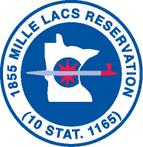

Mille Lacs Tribal Police Department
43408 Oodena Drive
Onamia, MN 56359
Phone: 320-532-3430
FAX: 320-532-4190

Dog Registration Form

Name of Owner:
Address:
Phone Number:

Dog Tag #:

Dog Owner Signature:

***OWNER MUST PROVIDE A COPY OF CURRENT VACCINATION RECORDS AT TIME OF REGISTRATION***

Officer Accepting Form:

