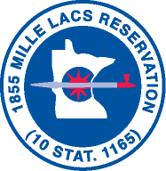

**Community Development**

**REQUEST FOR PROPOSAL**

**OWNER: MILLE LACS BAND OF OJIBWE DATE ISSUED: June 25, 2020**

**43408 OODENA DRIVE**

**ONAMIA, MN 56359 BID DATE: July 29, 2020**

**PROJECT: Headstart Playgrounds– District II and III**

**TO: Qualified Playground Equipment Contractors and General Contractors**

**THIS IS NOT A CHANGE ORDER NOR A DIRECTION TO PROCEED WITH THE WORK DESCRIBED HEREIN.**

**The Mille Lacs Band of Ojibwe, Community Development office will be accepting sealed bids for purchase and installation of playgrounds to be located at the Mille Lacs Band of Ojibwe Headstart facilities in District II and District III. Bids will be due Wednesday 29 July 2020 at 3:00 PM. Bids received will be opened and qualified by the Mille Lacs Band of Ojibwe on Thursday 30 July 2020 at 8:30 AM.**

**A mandatory pre-bid site visit will be held Tuesday July 14th at 10:00 AM. At the District II community center/ Headstart facility.**

**Directions to project site: From City of McGregor: Hwy 65 South 3.4 miles. Project site is on the East side of Hwy 65 .**

**General Notes:**

1. **Project is a Federal Davis-Bacon Commercial Project. As such certified payroll will be collected and all workers must be paid at or above the Commercial Davis Bacon Wage rate in force at the time of this RFP issue date.**
2. **It is the Contractors responsibility to identify any and all discrepancies in the scope of work, not meeting Industry Standards or that which is inconsistent with the International Residential Code (IRC), and Mille Lacs Band of Ojibwe 2020 MLB Project Specification Book.**
3. **All electrical wiring, apparatus and equipment for electric light, heat and power, technology circuits or systems shall comply with the rules of the Department of Commerce or the Department of Labor and Industry, as applicable, and be installed in conformity with accepted standards of construction for safety to life and property.**
4. **Contractor must reconnect all utilities, service panel or service feed. Also includes gas, propane. Include such equipment or materials identified in the pre-bid conference.**
5. **Contractor will secure all permits and fees.**
6. **Contractor is responsible for a thorough investigation of the scope of work.**
7. **Contractor will repair any damage to the property or structure created by the scope of work.**
8. **Contractor shall be responsible for all debris removal related to all work performed under this work scope.**
9. **NO WORK SHALL BE PERFORMED UNTIL ALL REQUIRED PERMITS HAVE BEEN ISSUED AND COPIES IN THE POSSESSION OF THE PROJECT COORDINATOR AND /OR MILLE LACS BAND BUILDING OFFICIAL.**

**COMMUNITY DEVELOPMENT WILL, TO THE GREATEST EXTENT FEASIBLE, GIVE PREFERENCE IN THE AWARD OF CONTRACT TO INDIAN ORGANIZATIONS AND INDIAN-OWNED ECONOMIC ENTERPRISES.**

**Work Scope Description:**

1. Playground equipment needed for age group(s) 2 to 10 years.
2. Budget amount for equipment only is $60,000.00 per location for a total equipment cost of $120,000. Owner will select preferred equipment package from 3 venders: St Croix Recreation, Midwest Playscapes, and Landscape Structures, Inc.
3. Please submit 2-3 designs for review from each vender.
4. Final color selections will be made by the Owner. Provide color package templates. Once selected, contractor shall produce selected color drawings for final approval.
5. Provide product data for all equipment being proposed and cost breakdown for all items.
6. Approximate size of playground base is 2050ft2 in each location.
7. Excavate base for playground equipment installation.
8. Install drain tile, border, rock, geotextile filter fabric. Include concrete ADA access point into the border.
9. Concrete for ADA ramp will have 12” sand cushion and rebar 24 inches on center in square grid.
10. Remove top soil to a depth of 10 inches to prepare site for playground equipment installation. Level area. Top soil removed separately for plastic timber boarder.
11. Supply and install 4” perforated corrugated drain tile w/ sock ran to day light with rodent guard installed.
12. Supply and install 1”-1 ½” rock to a depth of 4” following installation of playground equipment
13. Install geotextile filter fabric as per manufacturer’s recommendation over rock bed.
14. Supply and install 6”x6” **plastic** lumber boarder to 7” above grade, 4” below grade. Double layers with staggered seams fastened every four feet using 12” common spike nails.
15. Install poured rubber fall protection material to a depth of 9” above geotextile filter fabric.
16. Areas of top soil disturbed by the completion of items in this RFP are to be leveled and or infilled with black dirt and grass seed and starter fertilizer applied.
17. All Contractors and Suppliers must be licensed with the Mille Lacs Band of Ojibwe. Please contact MLBO Business Regulations office at 320-532-8859 for more information.
18. Project Location in McGregor, MN and Lake Lena MN.
19. Davis Bacon Commercial Construction wage rates apply.
20. All proposals must be on FY 2020 Bid Form.
21. Bid Alternate #1, eliminate continuous Pour in place rubber fall protection surface and add rubber mulch to all areas within playground border.
22. See maps below

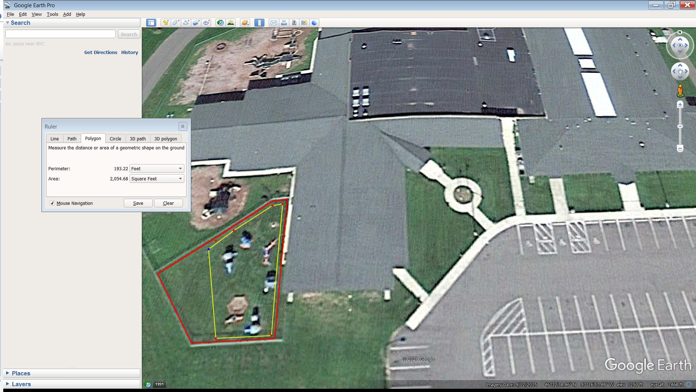

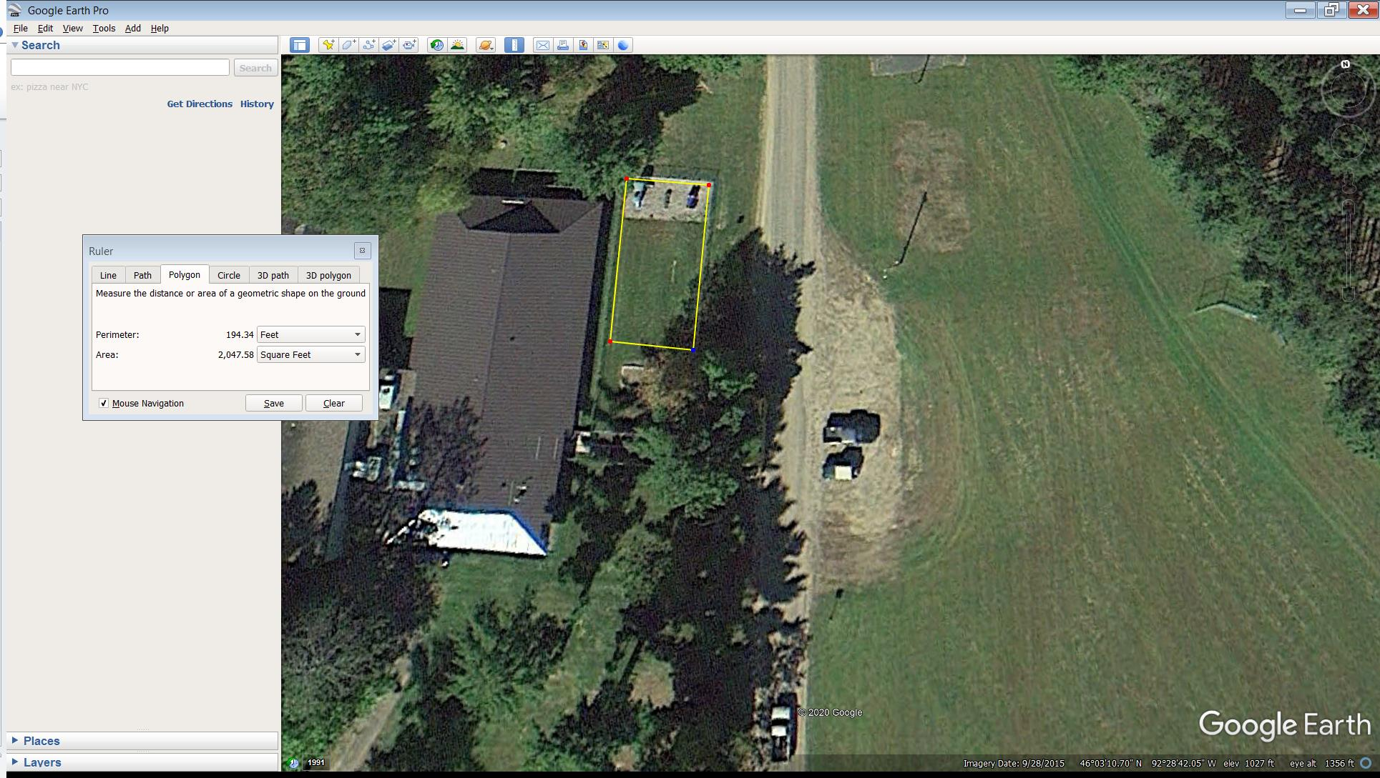

Contacts:

**Interested bidders shall contact Mike Moilanen at** [**mike.moilanen@millelacsband.com**](mailto:archie.cash@millelacsband.com) **to be included on the bidder’s list in the event that any addendums are issued for this project.**

Mobilization:

1. The Contractor shall be capable of mobilizing his equipment and crews within 6 weeks of the receipt of Notice to Proceed.
2. Contractor shall submit building schedule to Project Coordinator at the time of contract signature by the Contractor.
3. Contractor shall provide means and methods for all building phases of construction.

**COMMUNITY DEVELOPMENT/PROJECT MANAGEMENT RESERVES THE RIGHT TO REJECT ANY AND ALL BIDS FOR ANY REASON.**

Bidding notes:

1. Submit proposal in lump sum (supply and install), not to exceed amount
2. All Contractors (including subcontractors) must comply with Davis Bacon wage requirements.
3. All Contractors must provide the following along with their bid submittal:
   1. Completed and signed MLB Community Development Construction Bid Form
   2. A copy of Current MLB Vendor’s License (or a copy of the submitted application)
   3. A copy of Current Insurance Certificate
   4. Completed and signed copy of the TERO Compliance Plan
   5. A copy of Subcontractor/Material Supplier list
   6. A copy of Authorized Signature Sheet (submitted with first bid submittal)
4. All Contractors must comply with all Mille Lacs Band of Ojibwe American Indian Employment requirements (see 18 MLBSA § 5). Contact Craig Hansen at (320) 532-4778.

**All proposals MUST be mailed and labeled as follows:**

**Mille Lacs Band of Ojibwe**

**Commissioner of Community Development**

**Sealed bid: Headstart Playgrounds- District II and District III**

**P.O. Box 509**

**Onamia, MN 56359**

**Please note that the bids must be submitted via mail to the P.O. Box. FedEx and UPS will not deliver to a P.O. Box and the Onamia post office will not accept hand delivered items. Please plan accordingly to ensure the timely receipt of your bid submittal. **\*\***

**\*\*The Band reserves the right to reject any bid that it is unable to collect at the Onamia post office by the bid deadline date and time, provided that the Band has made diligent and reasonable efforts to collect the bid. The Band reserves this right even in the event that the bid has been postmarked before the deadline.**

**PROPOSALS NOT SUBMITTED IN THIS MANNER WILL BE REJECTED.**

Licensing:

1. Firms must be licensed with the Mille Lacs Band of Ojibwe. A copy of this license (or the license application) must accompany each bid. Licensing process can take several weeks. If you are not currently licensed with the MLBO, please submit a copy of your license application along with your proposal. Contact Jacquelyn Smith at (320)532-8240 or via email at [JSmith@mlcorporateventures.com](mailto:JSmith@mlcorporateventures.com) with questions regarding licensing and for the license application.

Permit and Contractor Requirements:

Permits: Contractors are responsible to attain all necessary permits for all work, including Mille Lacs Band of Ojibwe (MLBO) Permits. Mille Lacs Band Permit Fee is $50.00.

**Bonding Requirements: In accordance with 2019 MLB Project Specification Book.**

1. In construction contracts that are federally funded or deemed commercial, bonding is required. These types of contracts shall demand a performance bond not less than twenty (20%) percent of the total contract price, but not to exceed $500,000.00. A performance bond requirement is to ensure that, if a contractor defaults, the Band may request that the surety pay the expense incurred to complete the construction contract.
2. In addition, all construction contracts identified as federally funded or commercial shall be covered by a payment bond equal to one payment installment or cover subcontractors/suppliers as determined by the Contracting Officer or his agents. The payment bond must contain language stating that if the contractor fails to make a payment to its subcontractors/suppliers, the surety will make the necessary payment.
3. For all Band funded residential construction projects, a performance bond is required for contracts in excess of $50,000.00. The performance bond shall be at a minimum twenty (20%) percent of the contract price, but not in excess of $500,000.00.

SECTION II – BIDDING FORMS

Bidding Requirements and Contract Forms

COMMUNITY DEVELOPMENT

PROJECT MANAGEMENT

FY 2020 CONSTRUCTION BID FORM

REQUIRED FOR ALL BIDS

**FIRM NAME: __________________________________________________________________________**

**JOB/PROJECT: Headstart Playgrounds– District II and III**

**BASE BID LUMP SUM PRICE:**

**__________________________________________________________________$____________________**

(Written Value) (Dollar Amount)

BID ALTERNATE #1 (eliminate continuous rubber fall protection surface and add rubber mulch to all areas within playground border.)

**PRICE:**

**__________________________________________________________________$____________________**

(Written Value) (Dollar Amount)

**Acknowledgement of Addendum(s): 1) __________ date 2) ___________date 3) ___________date**

**BID GUARANTEE PERIOD:**

I agree to hold this bid open for a period of **90 days** after the bid opening. If this bid is accepted I agree to execute a Contract and/or a Purchase Order with the Mille Lacs Band of Ojibwe along with furnishing all required bonding (if required) and insurances.

**TERO COMPLIANCE:**

I understand that this company, its subcontractors and all employees performing work on this project will be expected to comply with all Mille Lacs Band TERO Compliance Regulations. Upon being informed that I will be awarded a contract for this project, I will submit all required TERO Compliance Plans directly to the MLB TERO Office for review and approval.

**Acknowledgement of TERO Compliance: _________________________**

**ATTACHMENTS REQUIRED: Failure to provide any of these attachments will result in bid disqualification.**

* MLB BID FORM (MUST BE SIGNED)
* MLBO VENDOR LICENSE
* COPY OF CURRENT INSURANCES
* LETTER FROM BONDING SURETY

**NAME: ________________________________________TITLE:________________________**

**SIGNATURE: _______________________________________DATE:____________________**

**FIRM NAME: ________________________________TELEPHONE:_____________________**

**ADDRESS: ____________________________________________________________________**

**EMAIL ADDRESS: ____________________________________________________________**